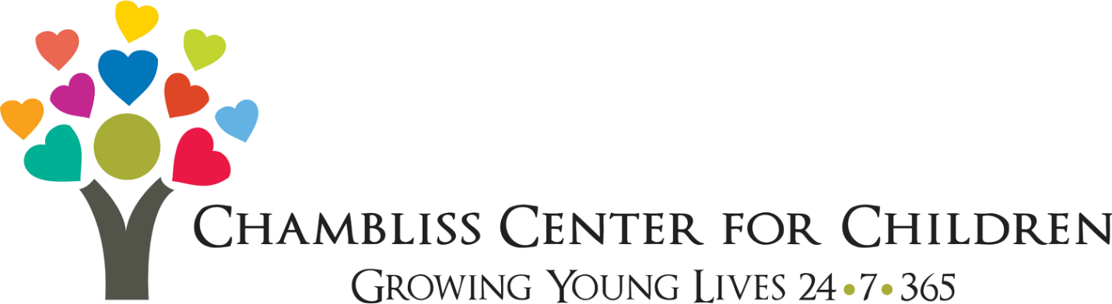

The Mission
The mission of Chambliss Center for Children is to enrich the lives of children, youth, and families by providing transformative programs and support services to meet the evolving needs of our community.

The Vision
To build a community where all children and youth have the foundation needed to thrive.

Services & Programs
Foster Care In Chattanooga, Cleveland And Surrounding Areas
Every child deserves to be a part of a stable and supportive family. The children we serve as part of our Foster Care Program are in State Custody due to abuse, abandonment, or neglect. We are seeking foster parents who can not only provide a safe and stable place to live but commit to nurture, teach, and strengthen the children and /or youth in their home while we find them a permanent home through reunification, kinship care, or adoption.
For more information, please call 423-693-2580 or email fostercare@chamblisscenter.org.

Extended Child Care In Chattanooga
Our Extended Child Care (ECE) program offers high-quality early childhood education and childcare to children from 6 weeks old - 12 years old on a sliding fee scale. The program operates 24 hours per day, 7 days per week and serves parents who are either working or in school. The goal is to provide the best possible education to young children, in preparation for Kindergarten, and to provide a safe place for our older children before and after school.

For more information, contact Levasia Green Associate Director of the Extended Childcare Program

Email: llgreen@chamblisscenter.org • Fax: 423.622.6549

Transitional Living
Chambliss Center for Children's Transitional Living Program provides stable housing and careful case management for youth who have aged out of traditional foster care at age 18 and have chosen to participate in Extension of Foster Care (EFC) services in the state of Tennessee.

For more information, contact Transitional Living Program Director Matt Davis at mgdavis@chamblisscenter.org.

For more information, please contact Chambliss Center for Children at:

Mailing Address: 315 Gillespie Road
Chattanooga, TN, 37411
Email: office@chamblisscenter.org
Phone: 423.698.2456
Fax: 423.622.6549 or 423.242.1670
Website: https://www.chamblisscenter.org/

