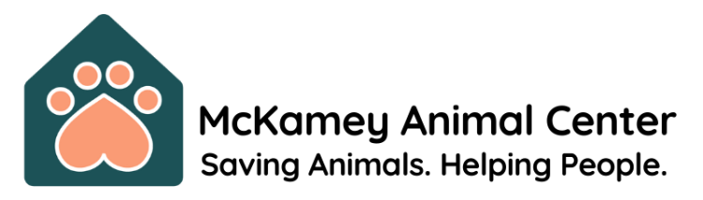
The Mission
Saving animals. Helping people.
The Vision

Create a culture of compassionate care, community engagement and advocacy for animals by providing programs and education that support people and companion animals throughout our communities.

Services
- Adopt a Pet
- Lost and Found Pets
- Rehome a Pet
- Vaccine and Microchip Clinics
- Spay and Neuter
- Community Cat Program
- Animal Protection
- City Licenses
- Pets for Life Chattanooga
- End of Life Care
- Pet Food Pantry
- Wildlife Resources

Get Involved
- Volunteer
- Foster
- Rescue Partners
- Special Events

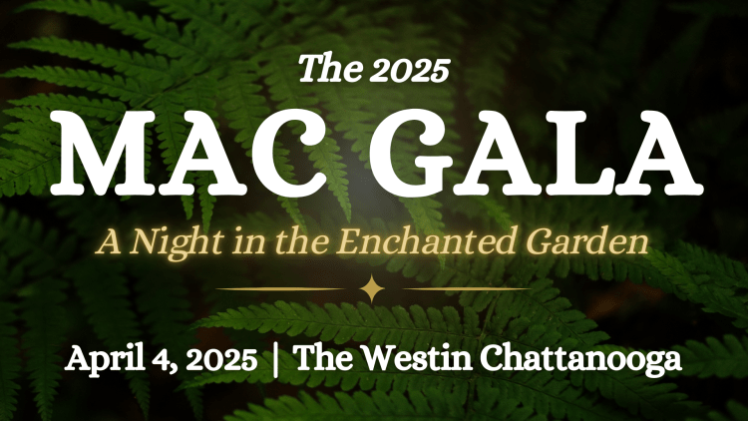

The MAC Gala is McKamey’s largest and one of the best fundraisers in town! This black-tie event raises critically needed funding to support the life-saving work of MAC. The event includes:

- Silent Auction with Mobile Bidding for More Than 100 Items!
- Live Auction with One-of-a-Kind Items!
- Snuggle Lounge with Adoptable Puppies & Kittens!
- The Best After Pawty in Town!
- Incredible Entertainment!
- Complimentary Valet Parking!
- And Much More!


Voted One of Chattanooga’s Top Fundraising Events in 2022 and 2024!

For more information, please contact McKamey Animal Center at:

Address: 4500 N. Access Rd.
Chattanooga, Tennessee 37415

Phone: 423.305.6500
Email: hello@mckameyanimalcenter.org
Website: mckameyanimalcenter.org

