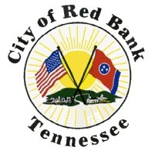

CITY OF RED BANK
FISCAL YEAR 2026 BUDGET
QUESTIONS AND ANSWERS

INDEX

PAGE | DEPARTMENT
1 | FIRE DEPARTEMENT
6 | POLICE DEPARTMENT
11 | MUNICIPAL COURT
13 | PUBLIC WORKS DEPARTMENT
18 | COMMUNITY DEVELOPMENT
21 | CITY HALL

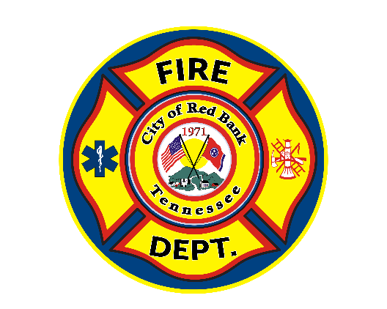

RED BANK FIRE DEPARTMENT
FISCAL YEAR 2026 BUDGET
QUESTIONS AND ANSWERS

Information about the Red Bank Fire Department:

The Red Bank Fire Department (RBFD) is comprised of 15 members who work full-time as their career, 27 members who receive compensation for working part-time shifts and are paid on call, and 6 volunteer members who receive no compensation for services rendered. The members of the RBFD are State Certified Fire Fighters. Included in the membership are Rescue (Vehicle, Rope) Technicians, Hazardous Materials Technicians, Paramedics, Emergency Medical Technicians & Emergency Medical Responders (EMR). The members are continuously going through training in order to be efficient and abreast of the latest strategies and tactics. This is necessary in order to provide an effective, well-coordinated fire department with standard methods and procedures of operation.

What has increased the personnel costs of the fire department?

The cost-of-living adjustments (COLA) for all personnel maintains our commitment to being an “employer of choice” providing competitive wages and great benefits costing $22,865. With today’s fires burning hotter (synthetics) and faster (lighter less dense materials), it is important to start a conversation to increase on duty staffing in order to put more firefighters on the scene as quickly as possible to save lives and property. We have added $5,000 to overtime costs. As salaries rise, so does the hourly rate for employees. We also added $600 to the supplemental pay line (these monies are paid by the state of TN). We added this to be more in line with how many members are receiving the supplemental pay. The overall increase in the fire department budget is $39,457, with $30,438 in the personnel budget. Operations has an overall increase of $9,519.

Training: Why is there no increase in the training budget?

There were initially several increases in the training budget due to the rising costs of registration for conferences, training materials, and expendable supplies. Due to budgetary constraints, we were forced to reduce the budget back down to the previous year’s amount.

What are the goals of the Fire Training Division with the FY 2026 budget?

Our goal remains to provide our personnel with current, realistic, and high-quality training so that they can provide the highest level of service to our citizens. With the FY 2026 budget, we will continue to be able to send our personnel to specialized training, professional development opportunities, and expand our training facilities and capabilities.

What does Training Props and Expendable Supplies mean and where does it go?

The term “Training Props and Expendable Supplies” is fairly vague, but it’s because it covers the majority of our physical training supplies and facilities.

- Fire Training Structure: We are continuing to build out a three-story training facility adjacent to Station 2. As we have completed phases of this project, we have been able to integrate it into various training scenarios and evolutions. The next phases will be to finish the second story and build the stairs to the third story. Then we will begin work on the exterior of the structure, providing the anchors and safety features to allow for rope and technical rescue training.
- Training Props: In addition to the training structure, we have various props and training appliances on our training ground. A portion of this budget goes towards maintaining the current props and purchasing additional props, as needed.
- Expendable Supplies: Firefighting is a tough physical job. In order to replicate the challenges we face in the real world, we sometimes have to do tough, physical things in training. This usually involves cutting, breaking, or destroying something. A portion of this budget goes towards the supplies expended in this training, such as the plywood for the roof ventilation prop and the wood for the forcible entry door.

Why does the fire department spend so much money on Professional Development, Recertification, and Renewals?

As an all-hazards agency, we provide numerous services to the City and the citizens. To ensure our citizens receive the best available response, we must provide our personnel with the best available training. While the majority of training is conducted in-house, there are some skills, proficiencies, and credentials that require special training that we are not able to provide.

- Fire Department Instructor’s Conference (FDIC): Each year, we send 4 personnel to FDIC to attend hands-on training, workshops, and seminars. This conference is the largest fire training event in the world and provides our instructors an opportunity to learn from the best and brightest in the business. This opportunity is invaluable in allowing us to remain on the leading edge of updated strategies and tactics to combat the ever-changing emergency scenes.
- General Classes and Certification Courses: While we host several state certification courses in house, we still send personnel to specialized schools and training opportunities around the region, as needed. This includes the Southeastern Extrication School, Alabama Fire College, and the Tennessee Fire and Codes Enforcement Academy.
- Chief Officers Professional Development: To ensure that our leadership remains abreast of the issues affecting fire departments around the state, region, and country, our chiefs attend the Tennessee Fire Chiefs Association, and the Southeastern Association of Fire Chiefs conferences each year.
- Fire Investigators and Inspectors Professional Development and Recertification: Fire Investigators and Inspectors are specialized proficiencies that require advanced and accredited training to maintain their licenses and credentials. Each year, our Fire Investigator (CFI) and Fire Investigation Technicians (FIT) attend the Annual Training Conference for the Tennessee Chapter of the International Association of Arson Investigators (TN-IAAI), and the Inspectors attend the Tennessee Fire Safety Inspectors Association’s conference.
- Building Official Professional Development and Recertification: In addition to fire service training, Chief Sylar must attend additional training to maintain his building and codes inspector licenses.

Emergency Medical Refreshers and License Renewals: Although we host an in-house EMR refresher each year, our personnel that hold more advanced licenses have to attend a formal refresher outside of the department. This also covers medical license renewals for all personnel, as it is a requirement for employment.

Why has the contractual services line increased?

We contract with Hamilton County 911 to provide dispatch services for Red Bank. The fire department and the police department split those costs, and the fire department’s portion of the 10% increase is $2,882. We also saw an increase in our vehicle GPS fees of $360 annually. Total increase is $3,242.

Supplies: Why has this line increased?

With the cost of your everyday items going up, so do the same supplies we must buy for the fire department. This line item also has our Hurst tool maintenance and the SCBA annual flow test. It also has monies to maintain our generators and our required annual pumper tests. We have added $1,000 to the supplies line, $300 to the Hurst tool line and a new line of $1,000 to repair our SCBA. These “new” airpaks are now 7 years old and are starting to have some issues that that will need to be repaired to keep them in service. Total increase in supplies is $2,300.

Uniforms: Why has this line increased?

Two fiscal years ago we bought every member a second set of turnout gear. Now we must budget for the replacement of the current gear that we already have on hand. This allows us to replace the gear on a cycle of 6 to 7 sets per year. Every year these costs continue to go up. The department buys all uniforms for its members. We do not have a “uniform allowance”. We have found that it is much cheaper and easier for there to be 1 person to buy uniforms for all members. In the long run, it saves the City money. The costs of uniforms and turnout gear continue to rise. This year’s increase is $2,520.

Why is there such a drastic increase to Vehicle Maintenance?

Today’s diesel engines are more complex than ever before. They also require way more emissions equipment than a standard automobile with a gas engine. With this comes increased costs to repair the intake and exhaust systems. Our apparatus are expected to go from 0% to 100% in the blink of an eye. Sometimes issues arise such as turbos failing ($6,500) or exhaust systems failing (DEF $8,000). These issues require that the apparatus be replaced to keep it in-service.

Computer Maintenance, why the decrease in this line item? ($-1,701)

This is the line where we pay for our fire department records management software (no increase), our online training software and records retention. We will be transitioning to a new platform for our online training and forms, which will result in a savings of $1,701. We also added display boards ($850 each) at the fire stations last fiscal year. This allows us to have our calls from communications displayed when we receive them, and also shows directions, hydrant locations and other pertinent information.

What is included in the Machinery and Equipment line item and its costs?

The machinery line item is where we place items needed that have a life span of longer than 5 years. This year we have placed another component of our fire hose replacement plan. Last fiscal year I spoke about the age and condition of our fire hose. The National Fire Protection Association (NFPA) says the fire hose should be replaced every 20 years or sooner if it fails annual testing. With the help of the commission, we started the replacement of almost 20,000’ of 20+ year old fire hose last fiscal year. This is a continuation of that replacement by replacing 2,000’ of 1 ¾” attack hose and 2,000’ of 2 ½” attack hose costing $27,500. We budgeted $5,000 for the replacement of small equipment and for repairs to equipment. We have also budgeted for the replacement of 3 of our intake valves. The current valves have become obsolete and when they break (1 is broken now) it is not cost prohibitive to repair them. We have budgeted $6,000 for this project. We have a fleet of battery operated fans (smoke ejectors). Over time, the batteries have become a problem with constant issues and continually needing to be replaced. Makita has come out with a new battery platform, and we have changed over 2 of our fans as a test to see if they work better. The results are that the Makita battery platform is much better. We have budgeted $6,000 to finish the conversion of 4 fans.

Our final request in this line item is a battery operated stair chair. A stair chair is a device used for the transport of patients up and down stairs in tight environments with limited manpower. The RBFD operates 2 engine companies with 2 members on each one. We run approximately 250 “lift assist calls” per year and those are anything from the “help I’ve fallen” to citizens needing help up steps they can no longer navigate. With this device it will allow 2 members to seamlessly and safely help those citizens back up the stairs without having to carry them possibly causing injury to them. This request was initiated by the members from the operations division, who after running calls that required this type of device to move patients safely and effectively, requested that we budget for said device.

RED BANK POLICE DEPARTMENT
FISCAL YEAR 2026 BUDGET
QUESTIONS AND ANSWERS

Regarding your budget proposal, your personnel costs have increased from last year. What does this include?

The bulk of the personnel costs includes 2.0% cost of living adjustment (COLA), which is applied to all City employees. This adjustment also increases other personnel costs such as retirement, social security, etc. Personnel costs also includes supplement pay to help compensate officers who have additional duties and higher standards such as members of special operations teams. This year, the City picks up the full salary cost for the Violent Crimes Detective that was previously paid for through the VCIF (Violent Crimes Intervention Fund) grant.

Regarding operation expenses, your contract services increased over last year. What is the reason for the increase?

This line item includes a few routine increases for services from some of our vendors, which include some automatic percentage increase each year. The bulk of the costs included an increase in the fee we pay to Hamilton County Communications Center for our dispatch services which was an approximate $25,000 increase.

There are a few increases in your operation expenses, such as wrecker services, cellular telephones, and travel. What do these increases include and what are the needs?

Wrecker fees have not been adjusted in many years and we are in the process of revising the wrecker ordinance and costs associated with that. In anticipation of the updated ordinance, wrecker fees will increase and as a result, our costs will go up.

Cellular costs increased some due to the addition of the new in-car computers and in-car camera systems which needs cellular technology to work.

This last year, we found out that training and travel costs increased more than we expected., In order to keep the same level of service to cover costs for travel, this line item needed to be increased.

There is a decrease in the Debt Services line item 600 as well as the Capital line item 940 for Machinery and Equipment. What is the reason for the decrease?

Debt Services line item decreased due to previous loans expiring. Last year, the police department purchased 6 vehicles and did not purchase any for this upcoming budget. Therefore, there is no Capital expense for line item 940.

As a note, the Debt Services line item includes the cost of loan payments for major purchases for the police department such as vehicles.

Why does the police department have the number of employees they have; how is the number of officers determined?

Staffing levels are based on several factors including community size, crime trends, response time goals, call volume, and officer workload. The goal is to ensure adequate coverage so officers can respond quickly to emergencies, conduct proactive policing, train adequately, investigate crimes, properly staff city sponsored events, and engage with the community.

The number is calculated using a combination of national standards, local data (such as calls for service and crime rates), geographic coverage needs, and time officers need for training, paperwork, court appearances, community engagement, and collateral duties. The aim is to maintain a balanced workload and effective policing.

What happens if the department is understaffed?

Understaffing can lead to longer response times, increased stress and burnout for officers, reduced community policing efforts, limited investigative capacity, training challenges, and potential increases in crime. It also impacts morale and retention within the department.

Why does the department need to maintain staffing levels or hire even if crime rates are stable or declining?

Stable or declining crime rates often reflect effective policing and community engagement, both of which require sustained staffing. In addition, population growth, attrition, retirements, and the complexity of modern policing (e.g., mental health calls, cybercrime) all require ongoing investment in personnel.

How does proper police staffing impact community safety?

Proper staffing ensures officers have the time and resources to not only respond to emergencies but also to build relationships, engage in problem-solving, train adequately, deter crime, and address root causes. It fosters trust, visibility, and a safer environment for all residents.

Why does the police budget include funding for support staff, not just officers?

Support personnel (such as record clerks and other administrative staff) are essential for operational efficiency. They handle administrative and technical duties, allowing officers to stay in the field and focus on core law enforcement tasks, which improves service delivery and cost-effectiveness. Red Bank Police Department is relatively lean in this regard, with two civilian support staff.

How does staffing relate to response times?

With proper staffing, officers can be strategically assigned and readily available to respond to calls quickly. Insufficient staffing forces prioritization of high-severity calls, potentially delaying responses to other important incidents.

What’s the long-term benefit of investing in appropriate staffing now?

Proactive staffing avoids future costs related to increased crime, overtime expenses, officer burnout, and public dissatisfaction. It supports recruitment and retention, helps maintain accreditation, and fosters a resilient, responsive department.

How does community growth affect staffing needs?

As the community grows, so do demands for police services. More residents mean more traffic, calls for service, community events, and enforcement needs. Staffing must evolve to match the community’s scale and complexity.
How was the current staffing level for the Red Bank Police Department specifically determined?

The Red Bank Police Department staffing level reflects the reality of policing in Tennessee. There is an increased demand for excellence, training, and technology.

To improve service delivery and provide law enforcement excellence, two police positions were added in 2023 for the FY2024 budget, bringing the department up to 26 sworn officers. The addition of these positions improved our staffing ratio, bringing us closer to alignment with agencies in our area, and increased our ability to adequately staff patrol shifts and send officers to training.

One of these positions created a Violent Crimes Detective in which the cost of the salary was covered for two years through VCIF (violent crimes intervention fund) grant funding. The second position allowed the creation of a Lieutenant position to supervise the entire patrol division.

In 2021, the Municipal Technical Advisory Service (MTAS) reaffirmed that the average staffing level of cities across the country is 2.4 police officers per 1,000 citizens. The average of Southern states was 2.7 (2.9 from another source) officers per 1,000 citizens. Many factors influence the need for additional staffing to include highways, retail and commercial development, commuting traffic, schools, hospitals, residential areas and more. The City of Red Bank has many of these factors. Using this information, police department staffing of 29 to 35 sworn officers would be justified. Staffing levels ratios in our area for 2022 were:

-Soddy-Daisy 2.17
-Signal Mountain 1.74
-Collegedale 2.26
-East Ridge 2.09
-Red Bank 1.96

Using this information, the City of Red Bank is comparable with nearby cities but towards the lower ratio of sworn officers.

With increased demands for police training and excellence, continued shortages due to injuries, medical leave, vacations and with the relocation of the county jail, the police department’s staffing coverage was often left at minimum. This increases workloads which leads to delayed responses to calls for service, increase in stress and stress related illness, injuries, fatigue, and low morale.

The 2 recently added positions brought the total number of sworn officers up to 26, which is still lower than the national or southern average, which would require adding 5 to 11 officers. The added staffing improves service excellence and assists with identifying the City as an “employer of choice”.

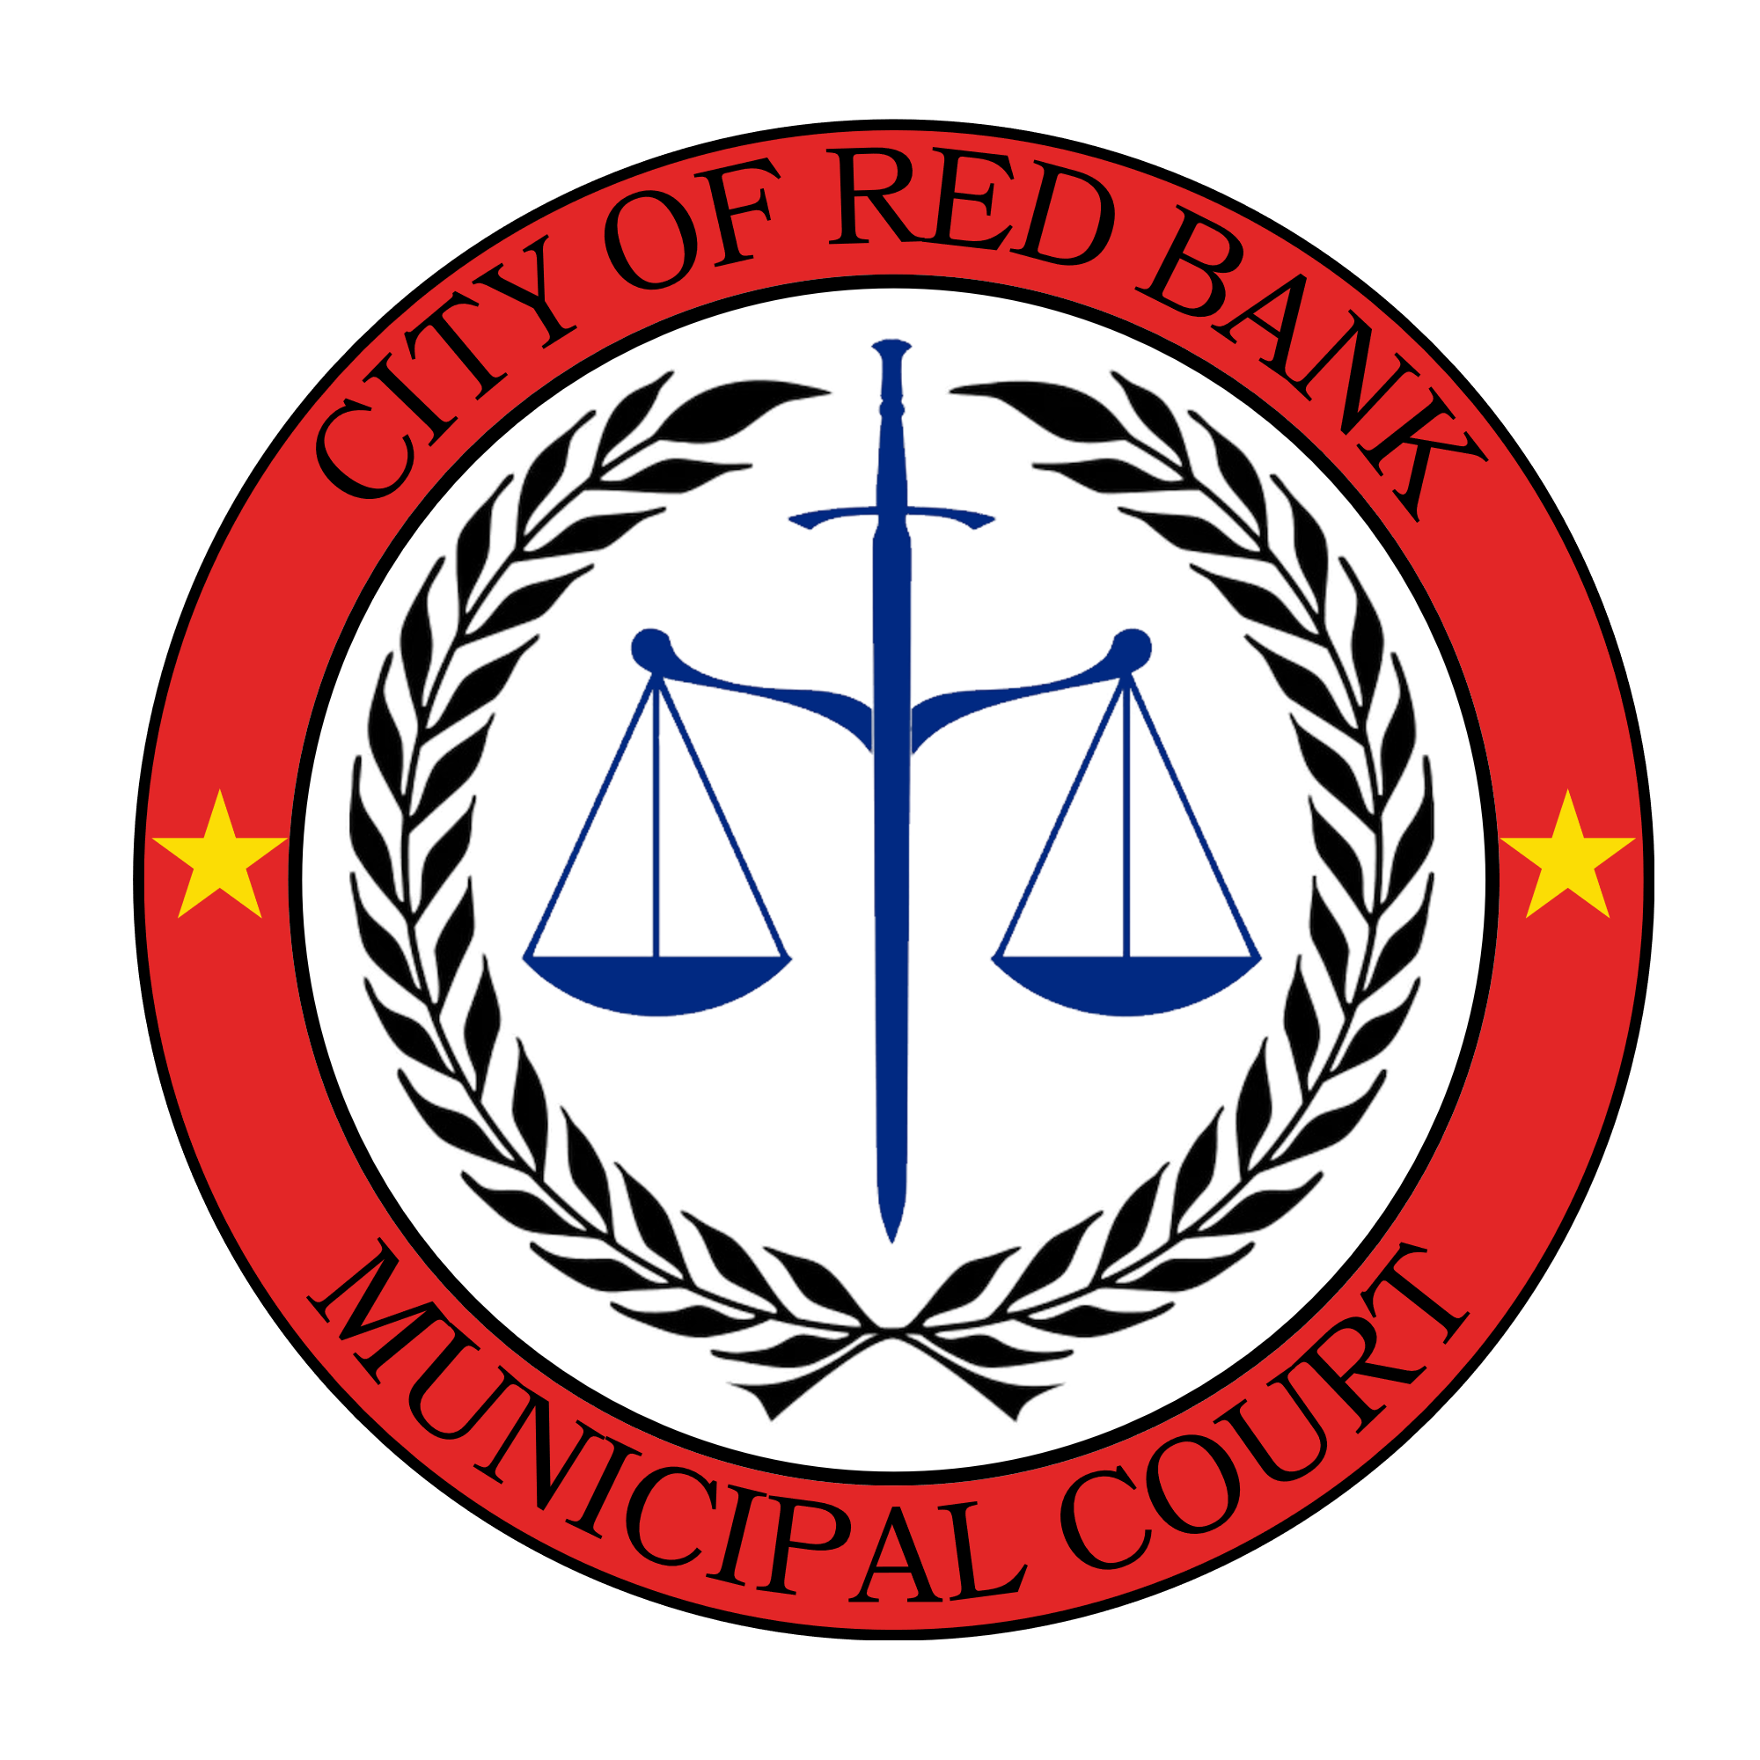

RED BANK MUNICIPAL COURT
FISCAL YEAR 2026 BUDGET
QUESTIONS AND ANSWERS

What is the purpose of the court system?

There are 4 basic functions of the court. Those are due process, crime control, rehabilitation, and administrative. Due process is focused on giving a person a fair chance to answer the charges they are facing. The court is tasked with the responsibility of issuing punitive measures to assist with crime control. The rehabilitation function of the court is to give treatment methods along with the disciplinary actions. And finally, the administrative function is more concerned the efficiency and speed of completing a case.

How many employees are in the court?

The staff is made up of 2 full time and 2 part time employees. The full time employees are the court clerk and deputy court clerk. The part time employees include the judge and a court assistant.

Are there any big changes in this year’s court budget?

No. There is a slight increase due to the cost of living adjustment. Overtime was slightly increased this year. This is because the court clerks are available after hours to sign warrants and make bonds. By being available to sign warrants, officers do not have to leave the city limits and go to the jail to have a magistrate sign them. This enables them to have paperwork signed and be back on shift quicker.

What are some things the court is working on this year?

We are currently working to digitize all court records. This will make our office more efficient and allow us to get records to the public much quicker. The court along with public works, reinstated the public work days program to help offset court costs for defendants as well as assist public works with keeping our streets free of trash. We are also looking into using a collection agency to assist with collecting past due costs and fines.

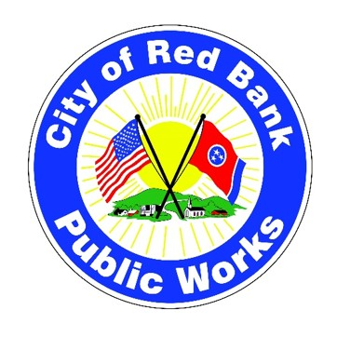
RED BANK PUBLIC WORKS DEPARTMENT
FISCAL YEAR 2026 BUDGET
QUESTIONS AND ANSWERS

Are there any major changes in revenue projections for FY-26 compared to FY-25?

No, over the past 3 budget cycles, revenue has remained stable across all 4 funds that support the Public Works Department. The General Fund allocation has not changed, aside from cost-of-living adjustments (COLA) and inflationary increases that continue to support the same core services (Administration and Streets, Fleet Management, Facilities Management, and Parks Management). Revenue for the Solid Waste Fund has also remained unchanged since 2009, with only minor annual fluctuations of ±3% from year to year, primarily due to the addition of new residential properties, or conversely, residents not paying their Solid Waste fees. The Storm Water Fund experienced increases in 2019 and again in 2023, resulting in a cumulative revenue growth of 36%; however, it has remained constant throughout the subsequent 3 budget cycles as demand for services have increased. The State Street Aid Fund has also remained steady for the past 5 years, with funding determined by U.S. Census Bureau per capita data for fuel tax disbursements.

Does the Public Works FY-26 budget include an inflationary increase, and if so how was it figured?

Pricing adjustments for goods and services have been applied in select categories—primarily operational supplies, fleet parts, fuel, and other expendable items—based on a 3% inflationary rate, in alignment with the Consumer Price Index at the time of this publication. In determining these adjustments, prior year expenditure trends were considered. Specifically, if a budget line item was under-expended in the previous fiscal year, an inflationary increase was not applied to that category for Fiscal Year 2026 operational budgeting.
How has the allocation for Transportation Public Safety changed in the FY-26 budget request?

The Fiscal Year 2026 budget request includes a 70% increase in the State Street Aid Fund allocation. This enhanced funding is intended to support specific Commission Goals, including the Development of Priorities for Safe Streets and Transportation Alternative Planning. Additionally, the increased allocation will fund the installation of new street signage and visual enforcement equipment aimed at reducing speeding, as well as planning activities related to improving sidewalk connectivity. As noted in Q1 above, the State Street Aid Fund is distinct and separate from the General Fund.

Are there any significant changes in the capital expenditure for FY-26?

The Fiscal Year 2026 budget request includes a significant increase in capital expenditures, with major allocations for vehicles and equipment, as well as funding for road resurfacing projects. The following is a breakdown of the proposed capital expenditures by fund:
Fund 110 – Streets Division (Account 110-43100-944)
- Acquisition of 1 electric (EV) pickup truck: $55,000
- Acquisition of 1 right-of-way mowing tractor equipped with a boom mower: $175,000
Total: $230,000
Fund 131 – Solid Waste Division (Account 131-43230-940)
- Acquisition of 2 electric (EV) pickup trucks: $110,000
Total: $110,000
Fund 121 – State Street Aid Fund (Account 121-43120-940)
- Acquisition of 1 dump truck with a salt spreader and snowplow attachment: $200,000
- Funding for secondary road paving projects: $700,000
Total: $900,000
Total Capital Funding Request: $1,240,000
(a consolidated loan shown as revenue and repaid as Debt Service for each separate fund)

The FY-26 Public Works Department (Streets, Fleet, Facilities, Parks) overall has about a $222,000 increase. What are the primary reasons for this increase?

The costs associated with this increase encompass personnel compensation and allowances, as well as the acquisition of capital assets. This division requires the replacement of aging service trucks and the procurement of a new tractor for mowing the right-of-way. Collectively, these purchases would result in approximately a 20% increase to the overall division budget. Utilizing Debt Service to pay annual lower rates for a Capital Loan will balance the budget while ensuring the provision of necessary equipment for daily operations in the upcoming year.

What provisions are made for emergency response and disaster preparedness in the FY-26 budget?

The Fiscal Year 2026 budget request proposes an increase in General Fund allocations to support overtime pay across supported divisions, specifically to enhance emergency response capabilities, disaster preparedness efforts along with after-hours events programming for select staff. Additionally, the State Street Aid Fund request includes the planned acquisition of a new dump truck, snowplow, and salt spreader to replace an existing 1999 unit that is no longer operational or suitable for winter weather street preparation. This expenditure is reflected under the Capital Outlay line item (see Q3 and A3 above) in the State Street Aid Fund budget request and is designated as Debt Service to account for the corresponding loan repayment.

Are there any changes in the FY-26 budget request for Public Works and city infrastructure maintenance?

The Fiscal Year budget request for the Facilities Maintenance Division reflects an increase of less than 3% compared to the previous fiscal year. Beginning in FY-26, responsibility for the maintenance of all facilities—including those within the parks system—will be consolidated under the Facilities Maintenance Division. While this results in a modest increase to the Facilities Maintenance budget, it concurrently reduces the Parks Facilities budget request by more than $121,000 compared to the prior fiscal year.

What are the anticipated changes in personnel costs in the FY-26 budget?

Personnel costs in the Fiscal Year 2026 budget request are projected to increase by less than 6% overall. This estimate is primarily driven by a proposed 2.0% cost-of-living adjustment (COLA), which is lower than the standard 2.5% annual adjustment historically applied by the Social Security Administration. Although the direct salary adjustment is 2.0%, this increase has a broader financial impact, as it also influences associated expenses such as retirement contributions, payroll taxes, and other employee benefits provided by the City.

Are there any new initiatives or programs introduced in the FY-26 budget request?

The FY-26 budget request introduces several new and continuing initiatives, including:
- Expansion of Programming: The Parks, Trails, and Recreation Division will broaden the scope of its programming. The proposed budget includes upgrading 1 staff position from part-time to full-time to enhance staff capacity for sustaining and improving existing programs as well as adding additional programming, as necessary.
- Sustainable Vehicle Procurement: The Streets and Solid Waste Divisions will leverage state-wide contracts to procure electric and/or hybrid vehicles, aiming to reduce the City's carbon footprint and fossil fuel consumption.
- Land Conversion Agreement: The Parks, Trails, and Recreation Manager, in collaboration with the Public Works Director and Community Development Director, will work to finalize the Land Conversion Agreement with the National Park Service and the Department of the Interior.
- Implementation of City Commission Goals: The Parks Division will implement the City Commission Goals, including the Parks Master Plan, and Low-Cost Activation of City properties, the build-out of the Godsey Ridge Trail, and the expansion of the Stringers Ridge Connector Trail.
- Capital Improvements: The City's Engineering Technician will lead a procurement effort to upgrade crosswalks throughout the city with enhanced safety measures and continue planning for sidewalk connectivity.
- Road Paving Plan: The Engineering Technician will also implement a secondary road paving plan, utilizing debt service repaid through the State Street Aid Fund, with no cost to the General Fund.
- Digital Signage Initiative: The Street Division will introduce digital transportation signage at entrances and key points across the city to reduce speeding, promote pedestrian and bicycle safety, and inform vehicle drivers. This initiative will be funded by the State Street Aid, with no expenditure from the General Fund.

The Storm Water Division has a $149,000 increase in total. Can you explain the large increase and what services or initiatives this is intended to fund?

The FY-26 budget request for the Storm Water Fund includes:
- An approximate 7% increase in personnel pay and allowances.
- Fees for Administration (budget line-171) have increased by $96,000 compared to the previous year. In prior years, Contract Services (Line 200) included annual funding for payments to the Hamilton County Tax Collector’s office for invoicing and collecting Storm Water fees from Red Bank residents and businesses. This funding has now been transferred to Fees for Administration (Line 171), which also encompasses payments to the General Fund for various common City expenses such as clerical/staff work, website maintenance, postage, and other support services.
- The Contract Services (Line 200) has been replenished with $80,000 in funding for engineering and other professional services to support Storm Water operations in conjunction with the newly adopted Storm Water Asset Management Plan.
- Additionally, minor capital funding has been allocated for the purchase of a new portable air compressor to be shared with the Streets Division for maintenance of the City’s storm water utility.
- Furthermore, it is important to note that the City’s new Jetter truck, purchased with ARPA funding last year, requires substantial amounts of water to perform its role. The cost of water was not previously budgeted in the Storm Water fund until this year, contributing to the overall increase.

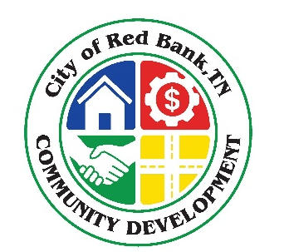

RED BANK COMMUNITY DEVELOPMENT
FISCAL YEAR 2026 BUDGET
QUESTIONS AND ANSWERS

What is the Community Development Department’s mission statement?

“To develop and implement strategies to enhance economic opportunity, build strong neighborhoods, promote public engagement, and ensure a dynamic framework for quality growth and development of Red Bank.”

What does the Community Development Department do?

To best utilize existing city resources and to provide more efficient and effective levels of service, areas of concentration with direct oversight for the Community Development Department include:

· Planning and Zoning
o Planning Commission / BZA
o Community Planner, Michael Pham
· Codes Enforcement
o Building Official, Eddie Clinton
o Administrative Hearing Officer, Jim Exum
· Stormwater Utility Administration
· Grant Research and Management
· Comprehensive and Strategic Planning Initiatives
· Economic Development Initiatives
· Contracts Management:
o Multi-Modal Engineering On-Call Services
o McKamey Animal Control Services
o CARTA – Paratransit Program
o Crown Castle - Cell Towers
o Marion Environmental
· Committee and/or Board Representative
o WWTA (Water/Wastewater Treatment Authority)
o CARGO (Chattanooga Area Regional Council of Governments)
o Public Art Citizens’ Advisory Board
o Non-Profit Citizens’ Advisory Board

What major activities will the Community Development Department focus on this fiscal year to support economic development?

Update Red Bank’s Land Use Regulations

The existing land use regulations including zoning, subdivision regulations and design review standards are outdated and not aligned with the goals outlined in the newly adopted Red Bank Comprehensive Plan 2025. To ensure the updated regulations are grounded in local priorities, support community values, and encourage economic development growth, the project will include robust stakeholder engagements through various public workshops and educational events.

Codes Enforcement

Effective code enforcement supports economic development by maintaining property standards, protecting public safety, and fostering an attractive, well-functioning built environment. By ensuring compliance with updated land use regulations and building codes, efforts in code enforcement promote investor confidence, support fair competition, and enhance the overall quality of life—key factors in attracting and retaining businesses, residents, and development opportunities.

Grant Sourcing

Grant sourcing efforts play a vital role in advancing economic development by securing external funding to support infrastructure improvements, small business support, and commercial revitalization initiatives. These targeted investments enhance the community’s capacity to attract investment and sustain economic growth.

Did the budget increase for the Community Development Department?

Yes, there is a budget increase for FY26. Overall, there is a budget increase of $20,640.00.

Personnel increase reflects a 2.0% Cost of Living Adjustment to all full-time staff.

Operations increase reflects added funds to continue library cards and special events.

RED BANK CITY HALL
FISCAL YEAR 2026 BUDGET
QUESTIONS AND ANSWERS

What is affecting personnel costs?
This year Social Security is offering a COLA of 2.5%. The City has proposed a 2.0% COLA to keep pace, although a bit behind Social Security, with projected inflation this year. This is in hopes of remaining competitive in the workforce and in accordance with our “Employer of Choice” goal.
What is “Employer of Choice”?
“Employer of Choice” encompasses competitive pay, valued benefits, engaged workers doing meaningful work, strong leadership, and an attractive workplace culture. In March of 2025, unemployment in Hamilton County was at 3%, 0.1% higher than the same time one year ago. The City of Red Bank has been able to keep turnover very low by focusing on this initiative.
Is the City increasing any benefits this year?
With the increase in the City-funded life insurance last year, Red Bank’s employee benefits package is very strong and attractive. Our workforce is beginning to start their career with us at younger ages, and therefore the needs of the workforce are changing. While not affecting the immediate budget, the City is opting to offer 2 weeks of paid maternity and 2 weeks of paid paternity leave to all eligible employees, beginning July 1, 2025. The eventual cost will differ, depending on when the recipient leaves employment and what rate of pay they are at when they leave.

