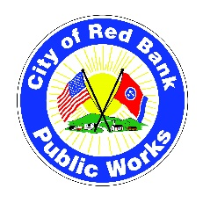
City of Red Bank
Public Works Department
3105 Dayton Boulevard
Red Bank, TN 37415
423.269-7927
www.redbanktn.gov

FY-2026 Public Works Department Annual Budget Overview
The Public Works Department is critical to maintaining and enhancing the infrastructure and services that support our community. This memorandum gives an overview of each division of the Department and highlights key goals for each in the upcoming fiscal year. It also serves as a guide to help you understand each division’s role in the budget process.

Divisions funded by the General fund (property taxes) include Administration, Streets Division, Fleet Division, Facilities Division, and the Parks Division.

In addition, the Public Works budget includes separately funded divisions (not property taxes) consisting of the Solid Waste Fund, Storm Water Fund, and State Street Aid Fund. These funds are proprietary and used only for those services.

The FY-2026 budget was prepared with a 3% inflationary increase based upon the U. S. Bureau of Labor and Statistics Consumer Price Index. Also factored in was a 1.5% COLA increase which is 1% lower than the Social Security Administration’s published 2.5% increase.

Divisions & Strategic Goals

Administration

- Develop a new Land Conversion Agreement with TDEC and the National Park Service, a key 2025 City Commission goal
(Lead: Greg Tate | Support: Leslie Johnson | Sponsor: Mayor Stefanie Dalton)

- Advance Safe Streets priorities by reducing speeding, improving pedestrian walkability, and protecting cycling routes, a key 2025 City Commission goal
(Lead: Greg Tate | Support: Chief Seymour | Sponsor: Commissioner Fairbanks-Harvey)

- Implement the Parks Master Plan to align with the City Commission’s long-term recreation and open space goals, also a key 2025 City Commission goal
(Lead: Greg Tate | Support: Jeffrey Grabe | Sponsor: Commissioner Hayes Wilkinson)

- Conclude the Public Works Needs Assessment in partnership with the city’s consultant, aiming to present initial plans for a Capital Improvements Plan before FY-27.
- Improve Pedestrian Safety through digital signage and enhanced crosswalks in collaboration with the city’s Transportation Safety Committee.

- Develop a City-Wide, multi-year Paving Plan using cost-effective resurfacing methods to extend road life (year one goal of paving $700,000 worth of roads-SSA-Debt Service).

- Continue City-Wide Guard Rail Replacement using contract services to improve safety and support city beautification goals.

- Establish a Recurring Pavement Striping Program to promote safety and maintain a clean, well-marked roadway network.

- Strengthening Community Communication and transparency on all projects.

- Pursue External Grant Funding opportunities to support future transportation projects.

- Maintain Service Excellence across all Public Works operations.

Capital Projects Administration

- Continue to oversight and monitoring to push our currently funded projects:
Project | Current Status
PIN 130155-Resurfacing Browntown to Gadd | Notice to Proceed to Construction-3/26/25
PIN 130774-ADA Upgrades Memorial South | Awaiting funding and Notice to Proceed to Initial Design-3/25/25
PIN 130563-Replace of Lullwater Bridge | Notice to Proceed to unfunded ROW/Initial Design-3/20/2025
PIN 135374-Red Bank Bike Boulevard | Pending a contract revision for Project Management costs as of 2/28/2025

- Implementation of a Sidewalk Connectivity Plan listed in priority order:
Sidewalk Connectivity Plan Ranked in Priority:
- Sidewalk from Greenleaf Street to W. Newberry St | Submitted to MPO for TAP Grant in 2026-2029 TIP Cycle
- Sidewalk and Traffic Control Improvements to Morrison Springs Rd at Red Bank High School | Submitted to MPO for TAP/TSMP Grant in 2026-2029 TIP Cycle
- Browntown Rd to Gadd Rd Sidewalk Connection | Submitted to MPO for TAP Grant in 2026-2029 TIP Cycle
- Sidewalks on E. Newberry St. to Easton Ave | Submitted to MPO for TAP Grant in 2026-2029 TIP Cycle
- Sidewalk on Easton Ave to the City Limits | Submitted to MPO for TAP Grant in 2026-2029 TIP Cycle
- Secure grant funding in the MPO 2023-2026 TIP Cycle for future infrastructure improvements through applications made to the Metropolitan Planning Organization.

- Application for Federal Safe Streets 4 All Grant for Action Planning.

Streets Division

- Labor Support for the Commission Goal of Creating Priorities for Safe Streets by curtailing speeding, enhancing pedestrian walkability, and protecting cycling routes.

- Labor Support for the Commission Goal of Implementation of the Parks Master Plan.

- Install smart speed limit and pedestrian signs across the city.
As a goal of the FY-26 budget, the Streets Division will install enhanced, digital speed limit signs at all entrances to the city, as well as points along Dayton Boulevard and Morrison Springs Road to support the Commission Goal of Safe Streets
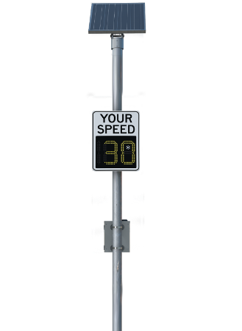
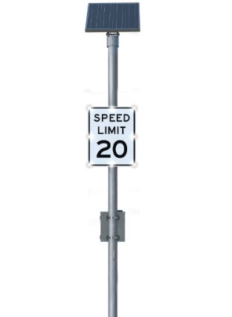
Funded through State Street Aid

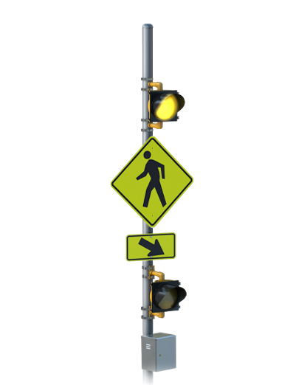
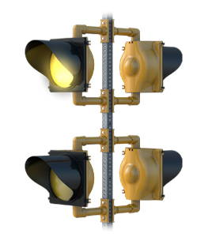
Another FY-26 goal is the implementation of similar style devices placed in advanced locations at all crosswalks along Dayton Boulevard with inclusion in all future connectivity plans . . .

- Continued support for the Cemetery Advisory Board activities at the Red Bank Cemetery on Oakland Terrace and the “Pauper’s Field” near E. Midvale Ave.

- Continue to support the Parks, Facilities, and Solid Waste Divisions with labor as necessary to sustain daily services.

- Purchase of EV pickup trucks for replacement of aged assets in the division ($100,000-Debt Service).
- Purchase a new tractor for Right-of-Way mowing to replace current asset with mechanical issue ($166,000-Debt Service)

Facilities Division
-  Enhance energy efficiency in municipal buildings with LED lighting, upgraded and energy efficient systems, and conservation measures to reduce costs and environmental impact.

- Centralize facility maintenance budgeting, including parks, under the Facilities Management budget for FY26.

- Expand routine maintenance programs to minimize the need for emergency repairs (HVAC service, roof inspections, generator inspections, etc.).

- Collaborate with city leadership on a long-term capital improvement plan for facility upgrades.
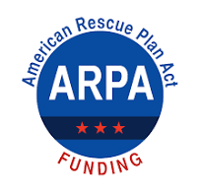

- Commission a follow-up City wide ADA Assessment to supplement the 2019 study by Wiser Consultants.

- Implement Facility Improvements with ARPA funding ($208,000) to include facility upgrades to Fire Stations 1 & 2 and the Police Department building in accordance with Resolution 22-1477 (no use of General Funds/Fund Balance).

- Continued Support for the Cemetery Advisory Board.

Fleet Division
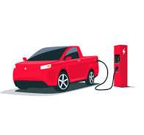
- Transition to a reduced emissions fleet with electric or hybrid vehicles where feasible.
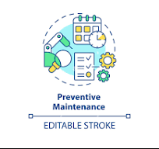

  - Reduce maintenance costs through predictive maintenance strategies and scheduling.

- Improve iWorQ fleet data collection and monitoring for efficiency and improved life-cycle management.

- Efficiently track downtime for all department’s fleet assets.

- Establish a Network of qualified automotive shops to provide contracted services.

- Replace shop equipment necessary to continue to perform in-house maintenance services (tire balancer, scan-tool software updates-$18,000)

- Improve vehicle operator safety by implementing regulatory standards in vehicle safety lighting throughout the Public Works Department (funded through each Divisions maintenance fund).

Parks Division

- Upgrade the Programming Assistant position from part-time to full-time.

- Recapitalize the Red Bank Dog Park (included in Facilities Management projects).

- Partner with Parks, Trails and Recreation service providers for improved services.

- Development of the Godsey Ridge Trail and White Oak Connector Trail.

- Maintain strong leadership and support for the Festival Advisory Committee and the Parks and Recreation Advisory Board.

- Develop an annual schedule for parks, trails, and recreational
programs in alignment with the Parks Master Plan, community
input, and guidance from the Parks and Recreation Advisory Board, led by Jeffrey Grabe.
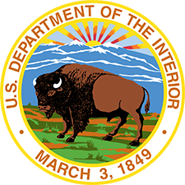
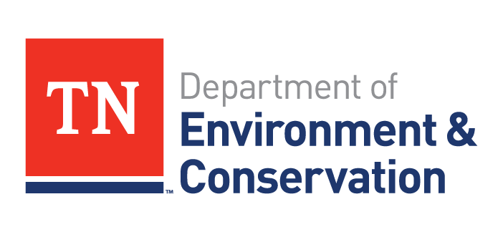
- Land Conversion Agreement with TDEC & LWCF
  - Conduct and Certify Appraisals – Ensure
that appraisals for both the converted
and replacement sites comply with the Uniform Appraisal Standards for Federal Land. Acquisitions (Yellow Book) and are reviewed by a certified state appraiser.
  - Prepare Mapping and Site Plans – Develop and provide boundary maps, location maps, and site development plans to ensure regulatory compliance.
  - Meet Environmental and Historic Standards – Complete environmental resource surveys, conduct a NEPA review, and secure SHPO approval for historic preservation.
  - Coordinate with Federal and State Agencies – Collaborate with TDEC, NPS, the U.S. Army Corps of Engineers, and the U.S. Fish & Wildlife Service to fulfill all regulatory requirements.

- Low-Cost Activation of City Properties
  - Support Community Development – Assist with labor and funding to activate city properties for public use, a key 2025 City Commission goal
  - Implement Low-Cost Enhancements – Install features such as benches, tables, and shade structures to improve short-term usability (Master Plan Reference: Page 102).
  - Pursue Medium-Cost Enhancements – Develop amenities such as a basketball court to further activate public spaces.
  - Align Improvements with the Parks Master Plan – Ensure all enhancements support the objectives outlined in the Parks Master Plan and promote accessibility and community engagement (Master Plan References: Pages 50-64 & 103-105).

Solid Waste Division

- Optimize waste collection routes for improved efficiency and reduced emissions.

- Increase recycling participation through education and outreach programs.


- Enhance customer service and response times for solid waste related services.


- Sustain the High Level of Service Delivery Excellence
of the Division through continued training and development of personnel (click link to see services offered through the Solid Waste Division).

- Increased funding for vehicles repairs (10% increase from last year).

  - Develop a Sustainable Capital Improvement Plan for the Solid Waste Division for future years.

- Purchase of EV pickup trucks and trailer for replacement of aged assets in the division. (Debt Service- $110,000)

Storm Water Division

- Reinforce the City’s Storm Water relationships with Hamilton County Water Quality, TDEC and the EPA’s mandate to enforce National Pollutant Discharges NPDES in our area.
- Adopt and activate the final Storm Water Asset Management Plan paid for through TDEC ARPA funding.
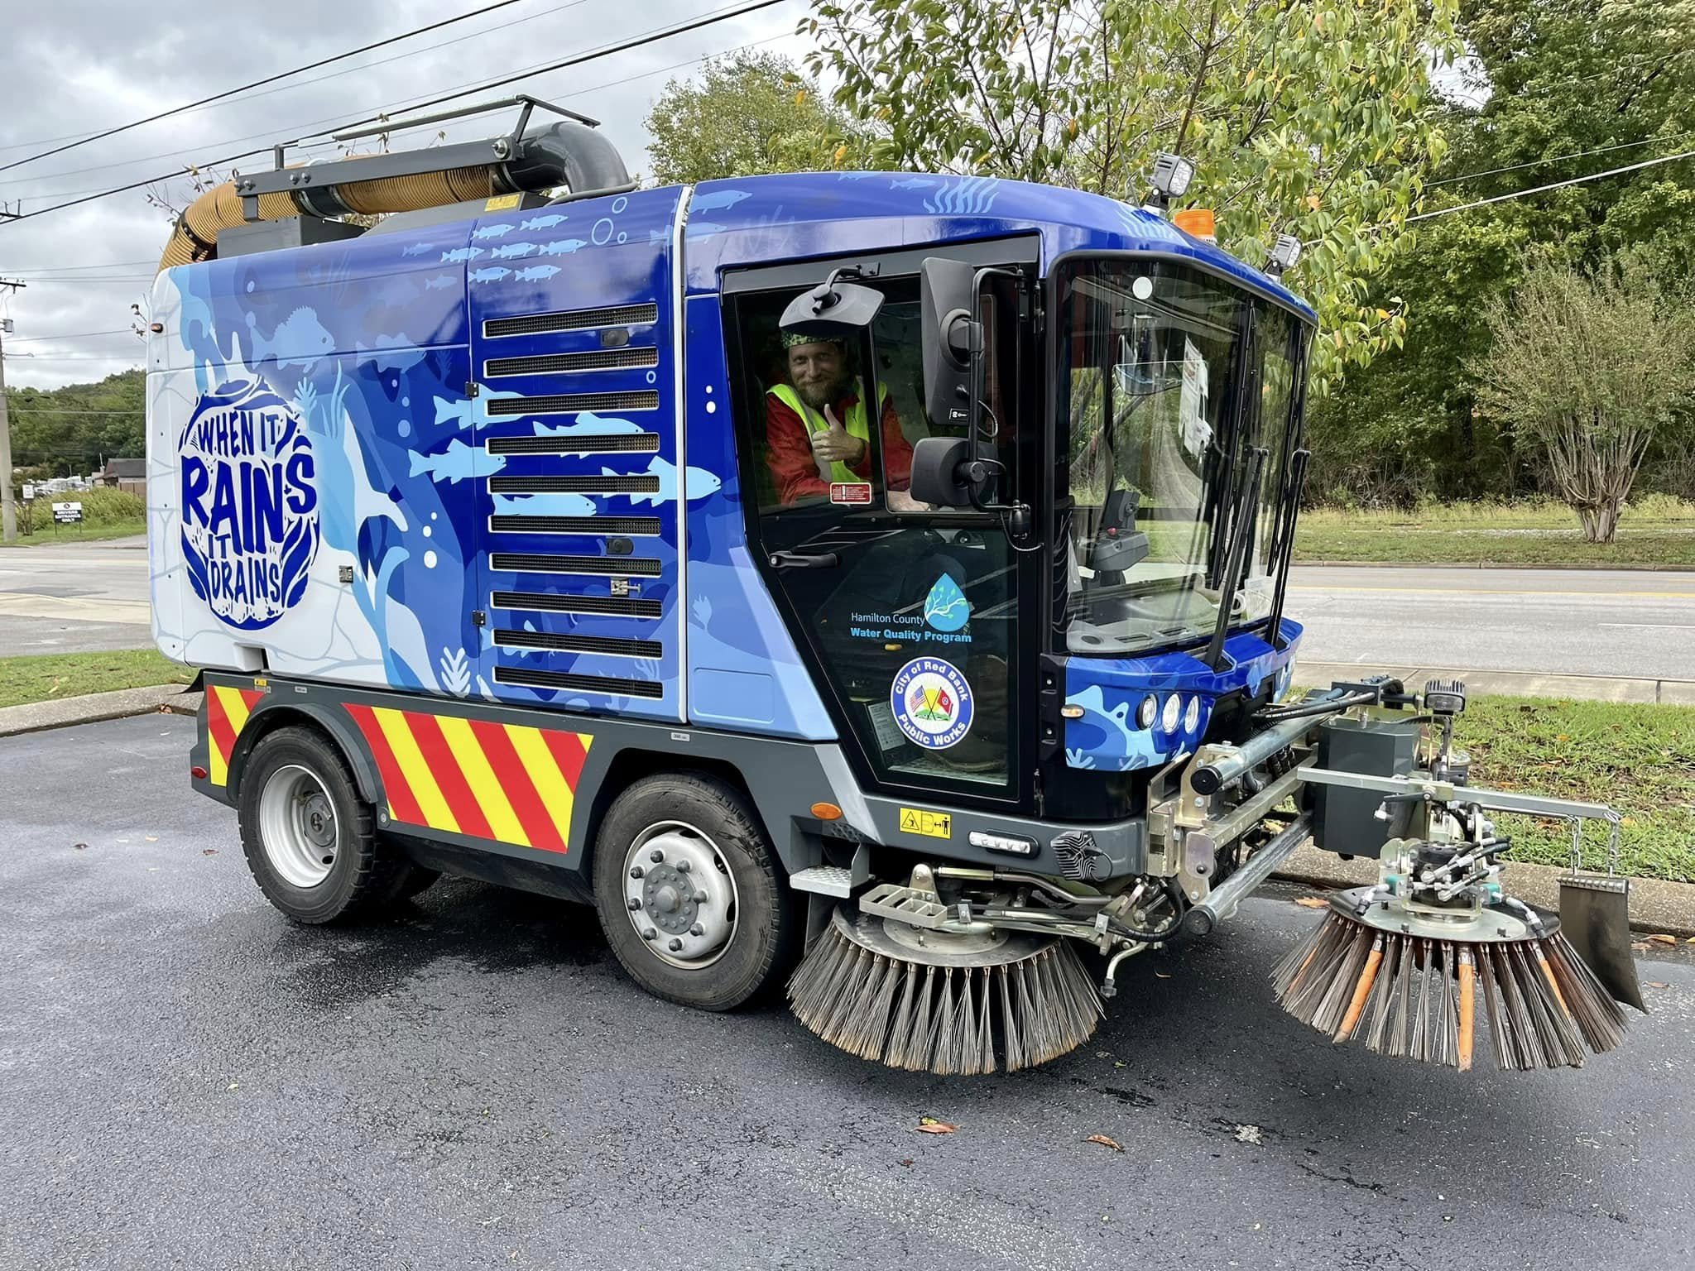

- Implement flood mitigation projects in high-risk areas through resident participation with the division’s on-line service requests.
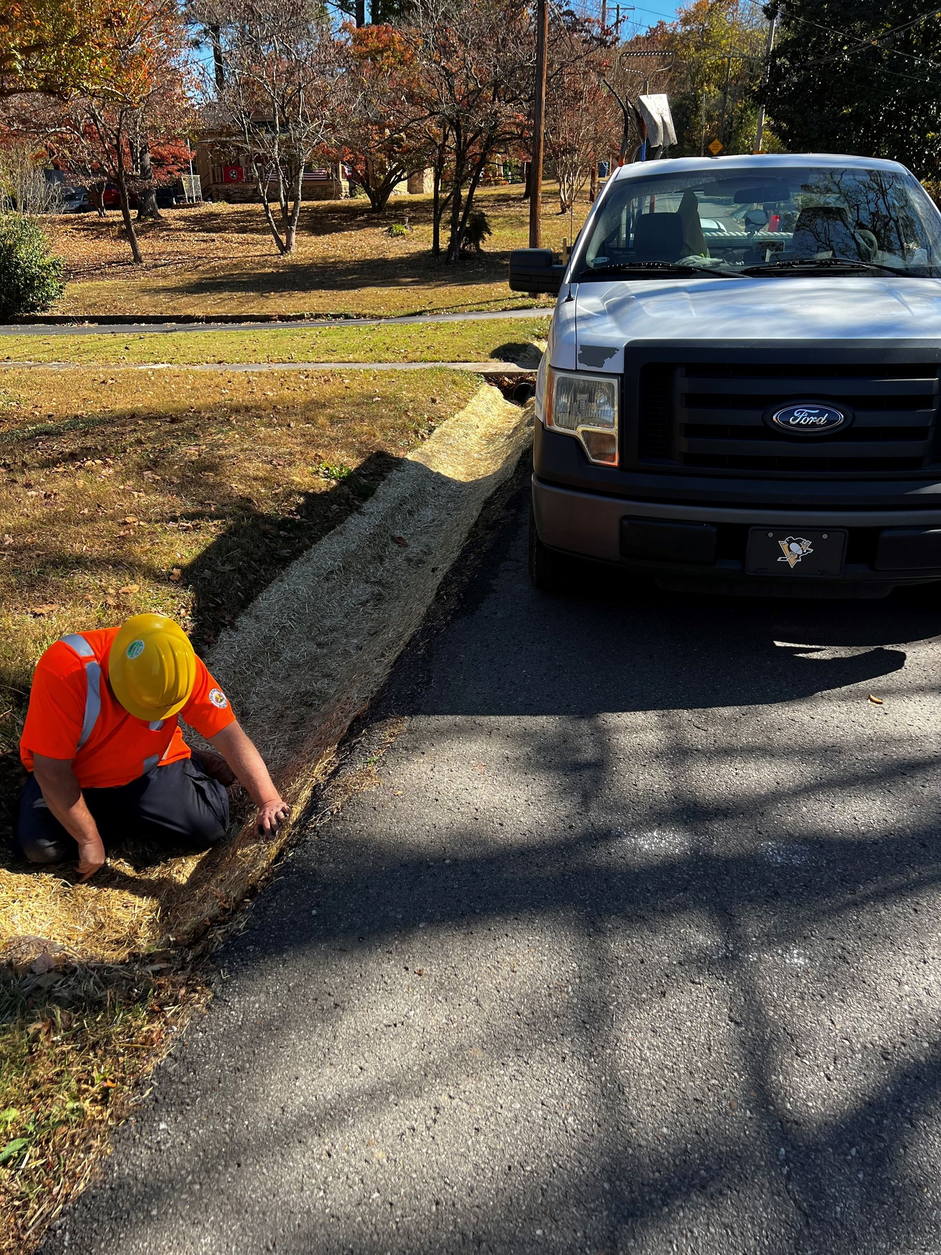

- Improve drainage system maintenance and debris removal programs.

- Increase funding for small Items of Equipment for special need items related to storm water utility maintenance (2,000).

- Enhance Public Education on storm water management and pollution prevention.

- Develop a Capital Improvements Plan aimed at generating additional revenue for stormwater infrastructure improvements.

- Upon adoption of the Stormwater Asset Management Plan by the City Commission, commence the execution of the City’s first Stormwater Utility and Maintenance SOP.

State Street Aid

- Fund pedestrian and bike infrastructure improvements for accessibility and safety.

- Upgrade street lighting and signage for better visibility, energy efficiency and safety.

- Fund critical capital projects pertaining to the city’s transportation goals.

- Develop long-term maintenance plans for the city’s road network.

- Strengthen partnerships with state agencies for coordinated grant funding.

Conclusion,
By strategically aligning our budget resources with our goals, we can achieve these goals all the while maintaining fiscal responsibility. Your support and dedication will ensure continued success in serving our community.

For any questions or input, please feel free to reach out. Let us make this a productive and successful year for the Public Works Department!

Respectfully,

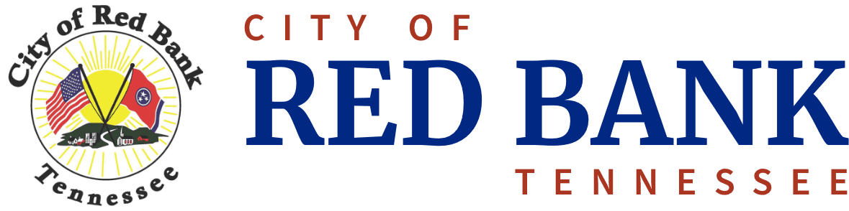
E-Mail Public Works
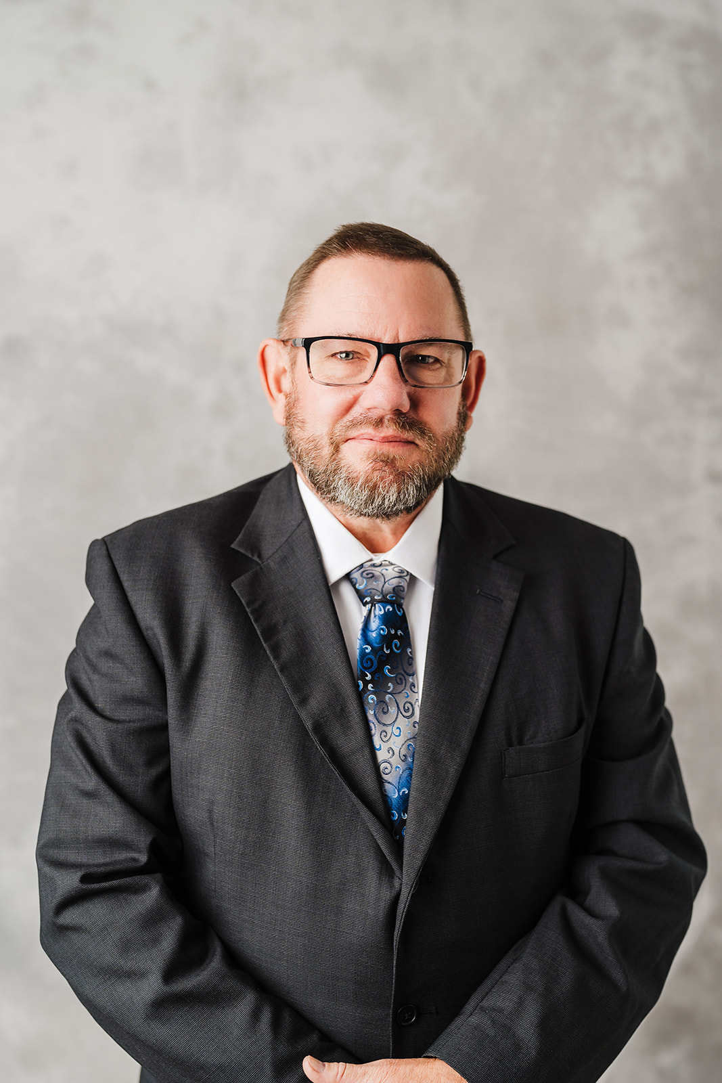

Greg Tate
Public Works Director
423-877-1103, Extension 2

